***Form***

***Carrer Objective***

ID a145df574f4000d10001

Roll number 10022145

Name of student XYZ

Fathers name ABCDEFG

Mothers name XYZABCDE

House / flat number 123

Colony XYZ

City ALLAHABAD

State UTTAR PRADESH

Pincode 211008

Mobile number 6XXXXXXXX0

Email id EXAMPLE @gmail.com

School name ------------------ school

Year of passing

class 12th 01-01-2000

Stream PCM/PCB/Commers

PCM

PCB

Commers

Roll number

300000000000

Roll number

200000000000

Roll number

300000000000

***Streams***

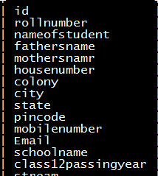

Idea Behind the program

* Form will be filled by a student of any of these main three streams.
* Python will classify the student’s roll number according the stream he/she is chosen.
* Then the records will be filled in the main table “**Carrer Objective**” automatically.
* There are six other sub tables namely :

1. PCM
2. PCB
3. Commers
4. PCM/Engennering colledge
5. PCB/Medical Colledge
6. Commers Colledge

* Then according to that data will be filled in these tables in contrast to main table.
* At last student will have to select colledge name from the given list as classified according to streams.

***Thank You***